Dashboard Design Report
Team ID | MCA
Project Name | Smartphone Usage, Digital Addiction & Well-Being Analytics
Maximum Marks | 5 Marks
Creating an effective dashboard involves thoughtful design to ensure that the presented information is clear, relevant, and easily understandable for the intended audience. Here are some key principles and best practices for dashboard design:
Activity 1: Interactive and Visually Appealing Dashboards
Creating interactive and visually appealing dashboards involves a combination of thoughtful design, effective use of visual elements, and the incorporation of interactive features. Here are some tips to help you design dashboards that are both visually appealing and engaging for users:
- Clear and Intuitive Layout: Organized into clear metric cards across the top with descriptive charts structured cleanly beneath.
- Use Appropriate Visualizations: Combines horizontal bar charts for categorical averages, donut charts for proportion distributions, and card blocks for simple volume metrics.
- Colour and Theming: Built using an accessible, high-contrast gray background layout with vibrant blue and accent tones for readable visual highlights.
- Interactive Filters and Slicers: Incorporates interactive slicers to dynamically filter data records globally across the view.
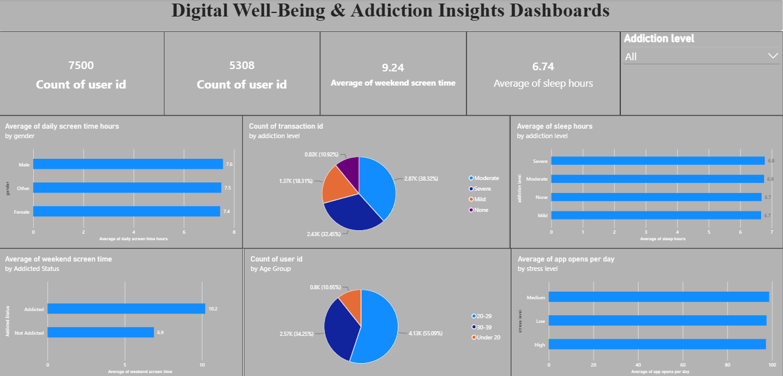

Major Outcomes of the Dashboard
Here are the key insights and outcomes derived directly from the provided dashboard visuals:
- Total Monitored Population Volume: The database tracks an active sample pool containing an absolute total of 7,500 user records, alongside a distinct processed subset count of 5,308 users.
- High Weekend Screen Engagement: Users average a prominent 9.24 hours of screen time during weekends, reflecting a substantial spike in device engagement during leisure periods.
- Rest Distribution Baseline: Across the entire surveyed cohort, the general population maintains a baseline of 6.74 average sleep hours.
- Uniform Screen Time Across Genders: Daily screen time remains highly consistent across all gender identities, with Males averaging 7.6 hours, Other genders at 7.5 hours, and Females at 7.4 hours.
- Dominance of Moderate Addiction Levels: The transaction count by addiction level pie chart reveals that Moderate behaviour claims the majority share at 38.32% (2.87K transactions), followed by Severe behaviour at 32.45% (2.43K).
- Stable Sleep Windows Across Addiction Severity: Average sleep duration remains tightly bounded between 6.6 to 6.7 hours regardless of whether a user's addiction tier is categorized as Severe, Moderate, Mild, or None.
- Addiction Impact on Weekend Leisure: Users tagged with an active Addicted status consume 10.2 hours of screen time on weekends, compared to a significantly lower 6.9 hours for Non - addicted users.
- Pronounced Young Adult Demographics: The age group breakdown demonstrates that the 20–29 cohort makes up the vast majority at 55.09% (4.13K users), followed by the 30–39 group at 34.25% (2.57K).
- Stress Level vs. App Interactions: Daily application utilization is exceptionally intense among the surveyed base, maintaining a steady baseline of approximately 100 app opens per day across Medium, Low, and High stress sub-segments.

